Experiment 1: Installation of Reinforcement Learning Environment
Install all the required software and check that they work.
Step 1: Install Anaconda
Download and install Anaconda for your operating system.
Step 2: Open Anaconda Prompt
Create a new environment:
conda create -n rl_env python=3.10
conda activate rl_env
Step 3: Install libraries
pip install numpy
pip install matplotlib
pip install gymnasium
pip install tensorflow
pip install keras
Step 4: Verify installation
import gymnasium
import tensorflow
import numpy
import matplotlib.pyplot as plt
print("Installation Successful")
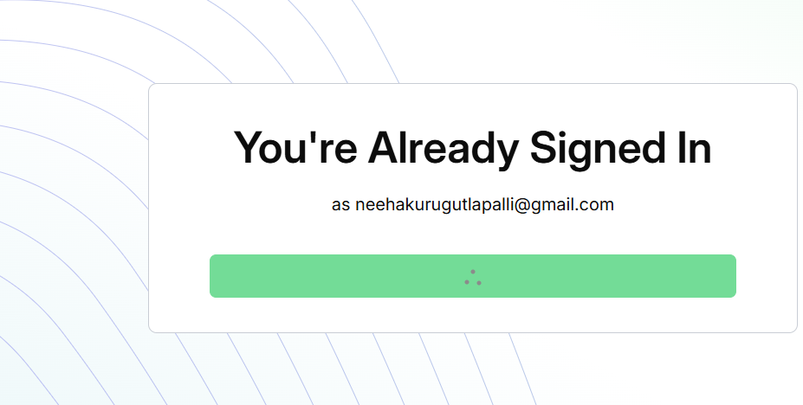


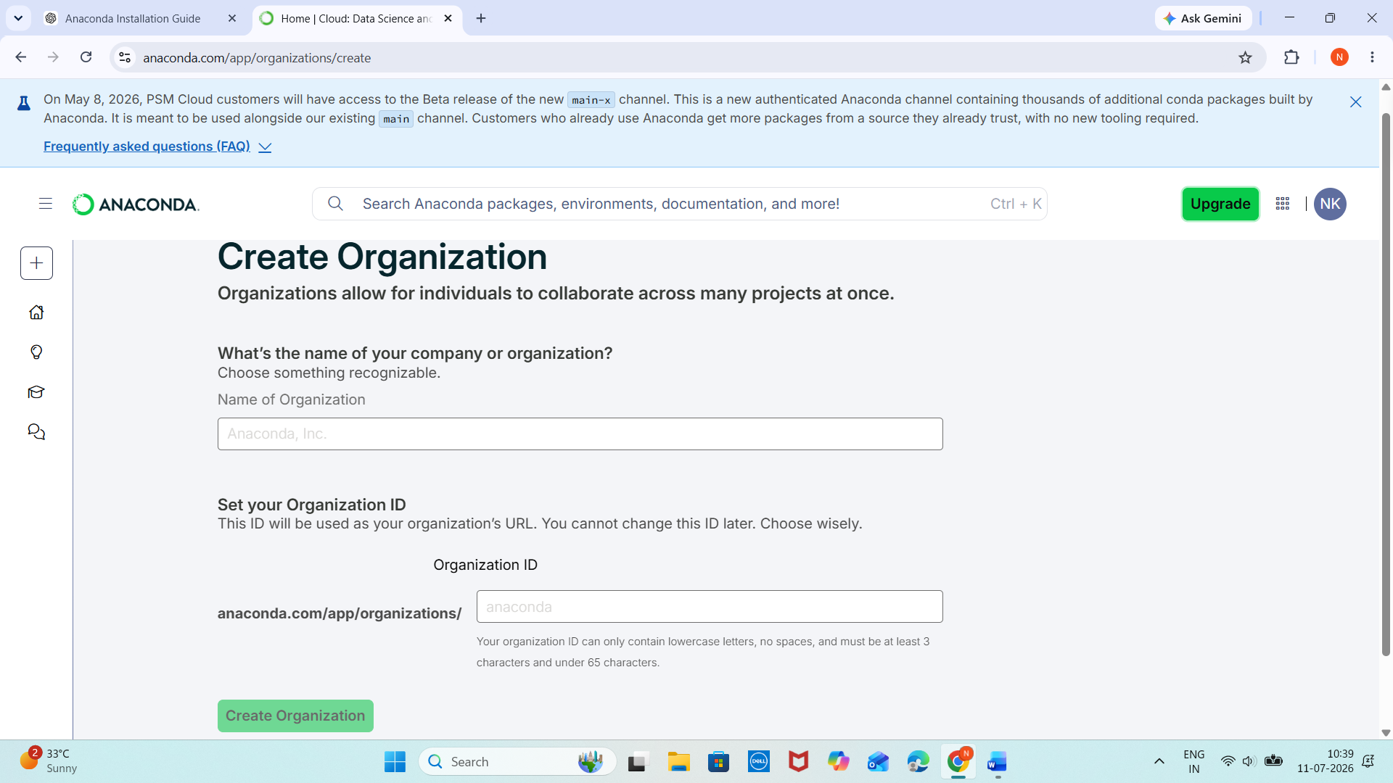

Experiment 2: Familiarization with Gymnasium
Objective
Understand
- Environment
- State
- Action
- Reward
OUTPUT:
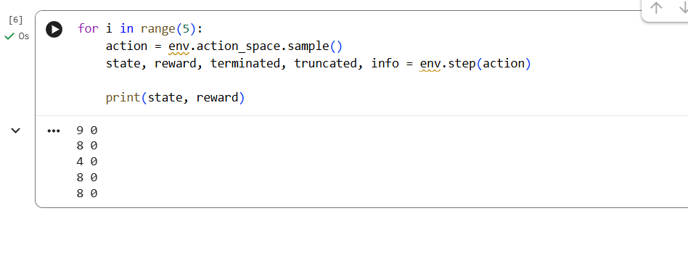

Experiment 3: Reinforcement Learning Framework
Learn this diagram
Agent
|
Action
|
Environment
|
Reward + Next State
|
Agent
Program
import random

states = ["A","B","C"]
actions = ["Left","Right"]
state = random.choice(states)
for i in range(5):
action = random.choice(actions)
reward = random.randint(0,10)
print(state, action, reward)
OUTPUT:
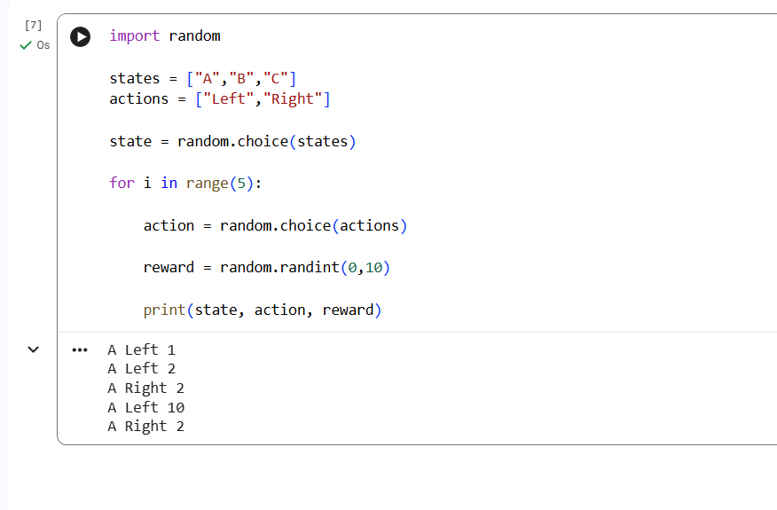Experiment 4: Markov Decision Process
Learn these terms
State
↓
Action
↓
Next State
↓
Reward
Example
Home
↓

Walk
↓
College
↓
Reward = 10
OUTPUT:
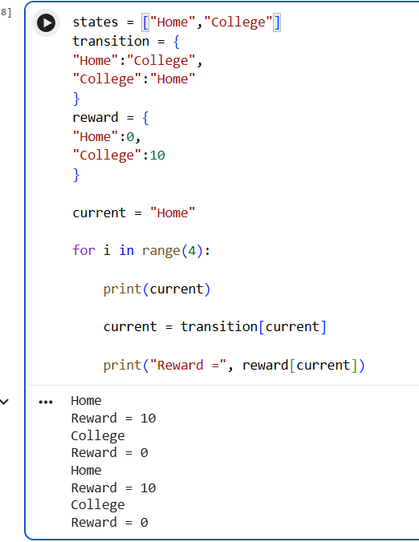
Experiment 6: Exploration vs Exploitation
- Random
- Greedy
- ε-Greedy
Example
import random

values = [10,5,8]

epsilon = 0.2

for i in range(10):

if random.random() < epsilon:
action = random.randint(0,2)
print("Explore", action)

else:
action = values.index(max(values))
print("Exploit", action)
OUTPUT:
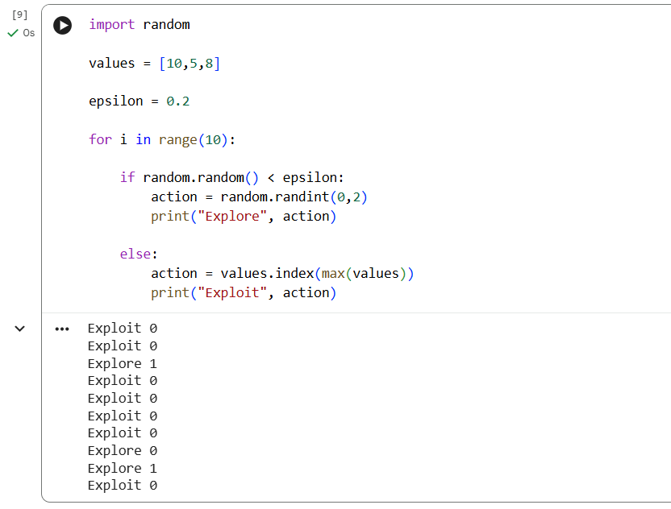
Experiment 8: Reward Visualization
import matplotlib.pyplot as plt
reward = [1,2,4,5,7,9,12]
plt.plot (reward)
plt.xlabel ("Episode")
plt .ylabel ("Reward")
plt.title ("Reward Graph")
plt. show()
OUTPUT:
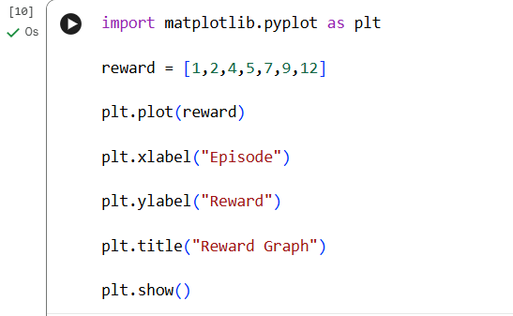
Algorithm:
- Initialize a list of rewards for multiple episodes.
- Store reward values obtained in each episode.
- Plot episodes on the X-axis and rewards on the Y-axis.
- Analyze the trend of the graph.
- Conclude the agent's learning performance.
import matplotlib.pyplot as plt

# Sample rewards for 10 episodes
rewards = [10, 15, 20, 18, 25, 30, 35, 40, 45, 50]

episodes = list(range(1, len(rewards) + 1))

plt.plot(episodes, rewards, marker='o')
plt.title("Reward Visualization")
plt.xlabel("Episodes")
plt.ylabel("Rewards")
plt.grid(True)
plt.show()

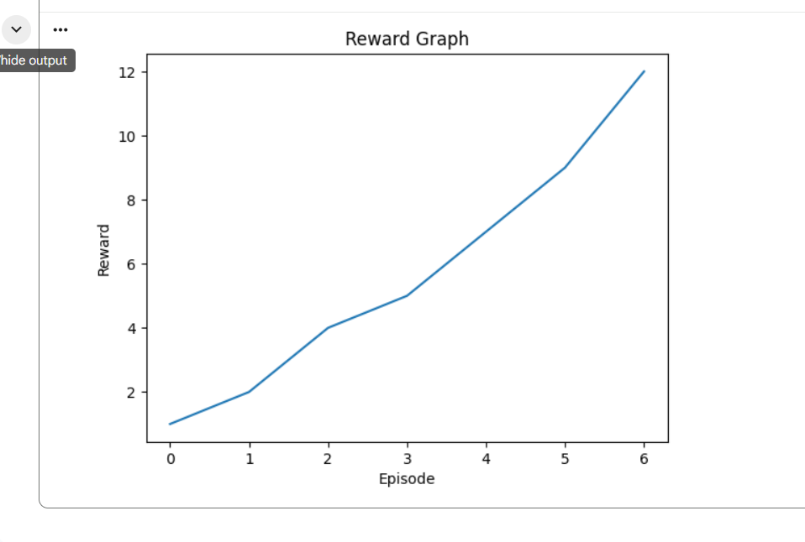

Experiment 9: TensorFlow Neural Network
from tensorflow.keras.models import Sequential
from tensorflow.keras.layers import Dense
model = Sequential()
model.add(Dense(24,input_shape=(4,),activation='relu'))
model.add(Dense(24,activation='relu'))
model.add(Dense(2,activation='linear'))
model.summary()
OUTPUT:
